Lab: Streaming CDC with Kafka and Debezium

Introduction
In this lab, we will be running Debezium on a remote EC2 instance to capture changes from a MySQL instance hosted on Amazon Relational Database Service (RDS). In addition, we will be streaming changes in near real-time and storing them in S3. You will see streaming and cloud storage services used in tandem to bring cloud data into a data lake.
We will continue to use a GitHub Codespace to automate infrastructure deployment and interact with cloud resources.

Pre-requisites
You should have a Codespace environment up and running in your browser with the following git repository cloned and open: https://github.com/UST-SEIS-745-DLE-Labs/lab-02-streaming-cdc-kafka-debezium.
Additionally, you should be familiar with the infrastructure as code and lab conventions we have used previously in class. When running the lab you will be interactively copying lines from bash scripts and pasting them into your bash terminal. Pay attention to the code you are executing and the output as you learn how to automate infrastructure deployment in AWS.
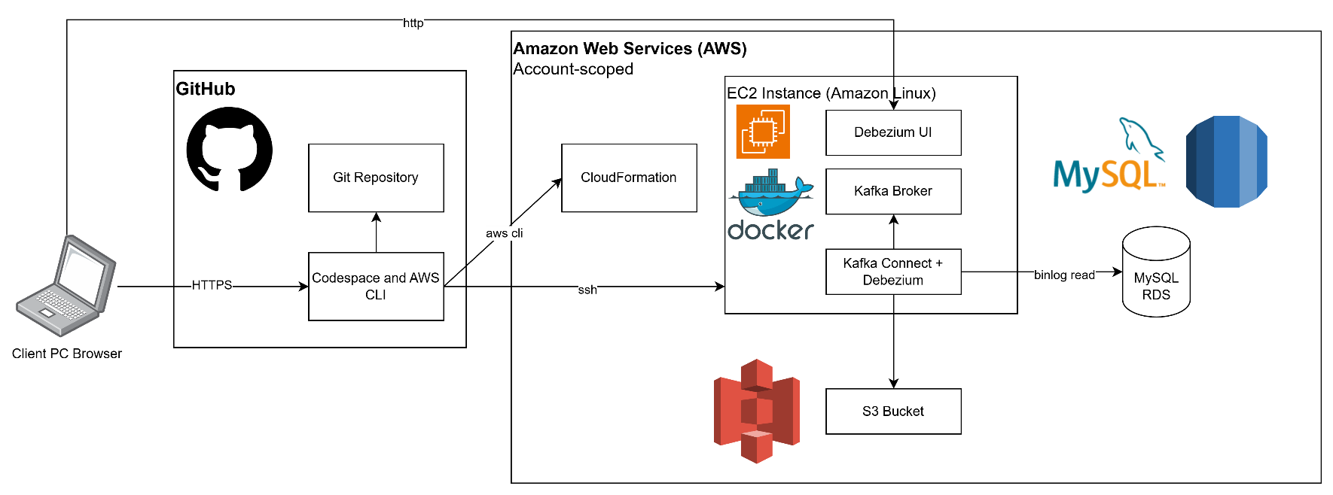

Section 1: Set environment variables and create an S3 bucket (or reuse an existing one)
- Once you have opened your Codespace and cloned the repository, it should look something like this:
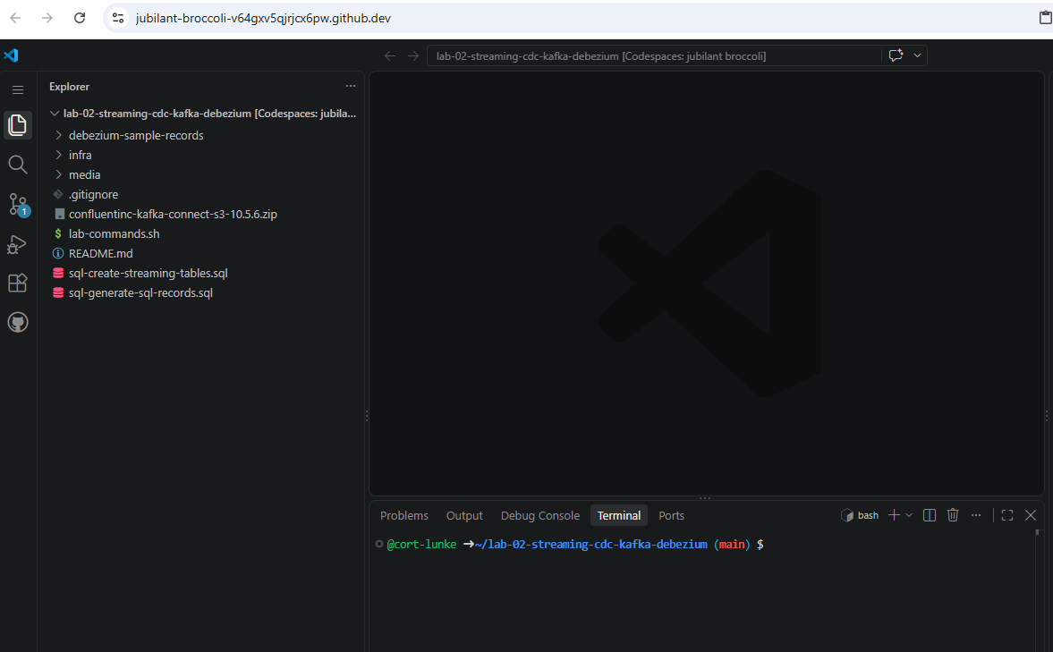
- First, open infra/lab-params.sh You need to update the CLIENT_IP variable with your IP address shown at https://checkip.amazonaws.com/. Don’t forget to save lab-params.sh after updating the variable (Ctrl+S on Windows)
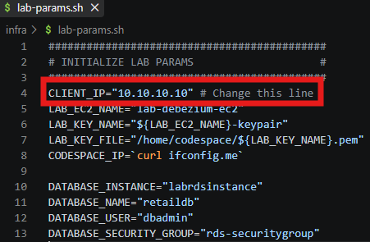

- Next, run codespace-init.sh to install lab dependencies and the AWS CLI. While it does not hurt to install the AWS CLI a second time, if you have previously installed the AWS CLI in this environment you may simply run the first and last executable lines (sudo apt and aws configure).
Just like Lab 1, you will need to get your AWS access key id, secret access key, and session token from your AWS Academy environment.
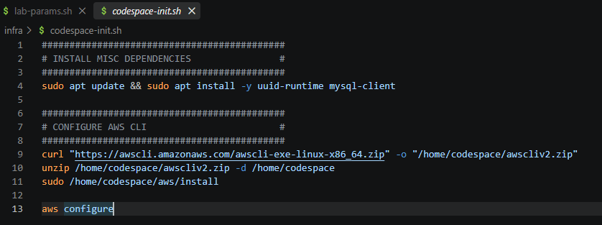

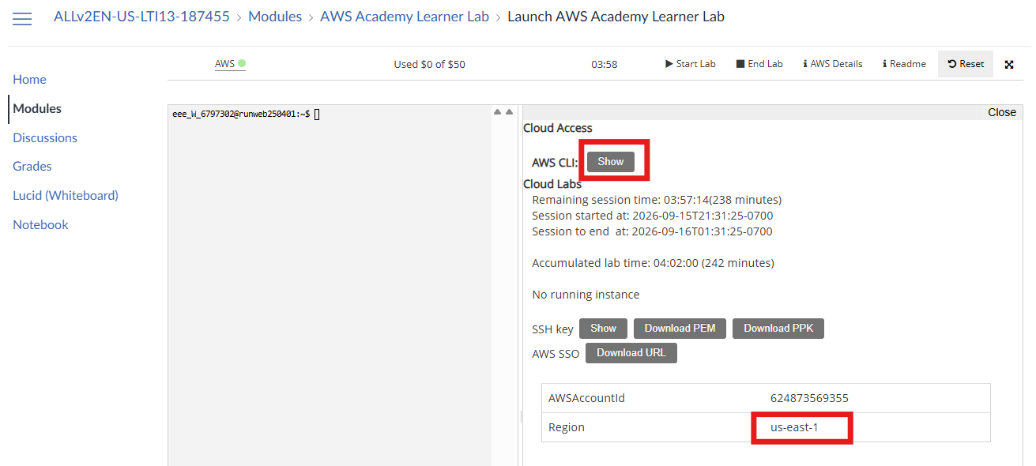

- Now that you have configured the AWS CLI and set necessary lab variables, we can start deploying resources. Open env-init.sh to start deploying lab infrastructure. The following lines of code initialize lab parameters, queries for an existing S3 bucket using the AWS CLI, and creates a new S3 bucket if one does not yet exist.
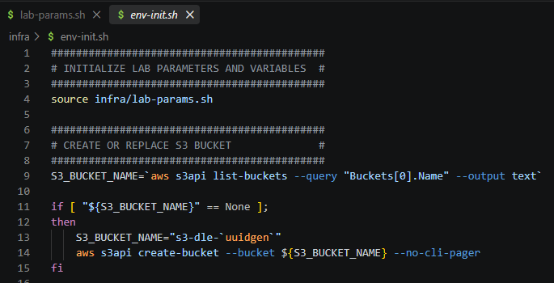
- You may double check that your bucket was created at https://s3.console.aws.amazon.com/s3:
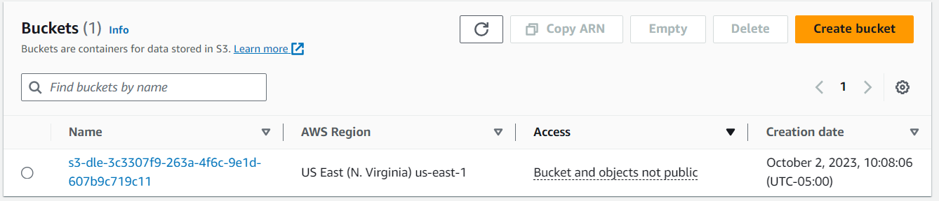

Section 2: Deploy an Amazon EC2 Instance for hosting Debezium
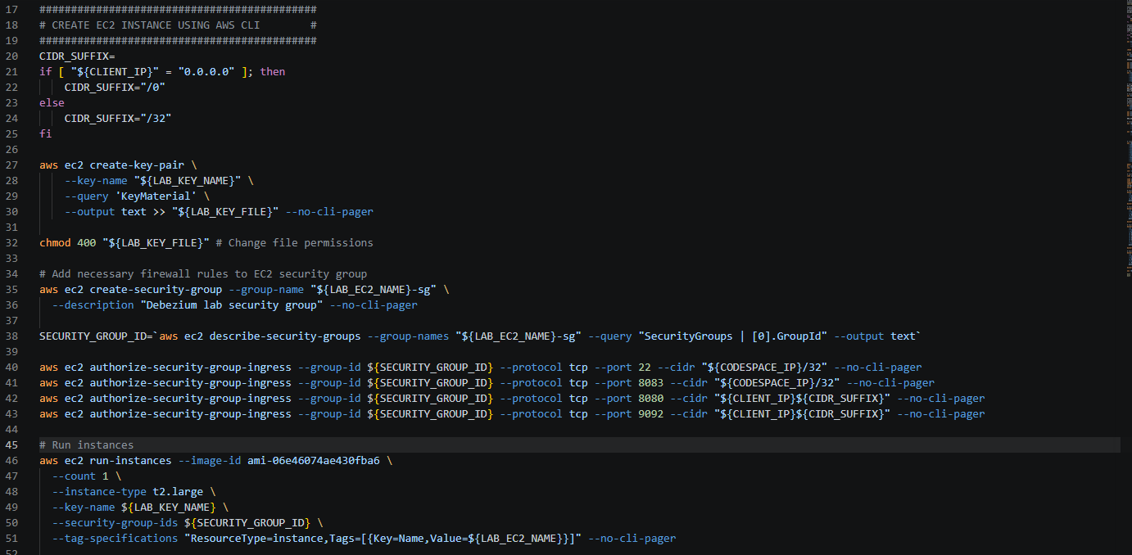
- The next step in env-init.sh deploys an EC2 instance leveraging the AWS CLI. Run this section of code to turn your client IP address into a proper CIDR range, create a keypair for authentication, create a security group and corresponding firewall rules, and run the instance:

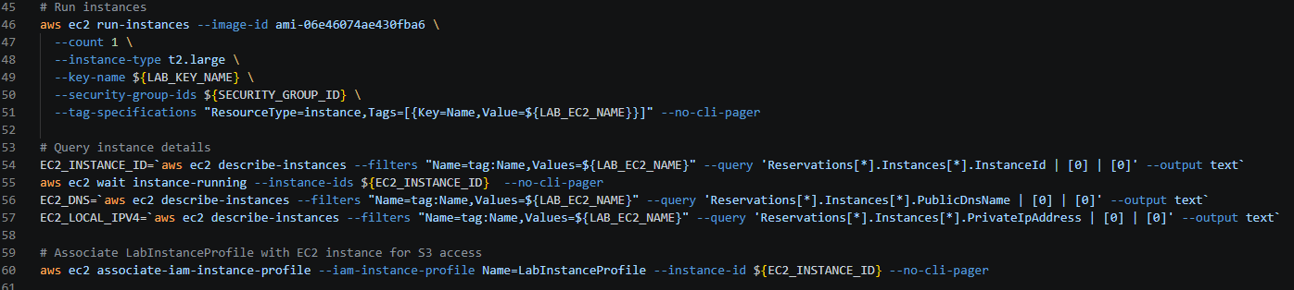
- This next section queries instance attributes and assigns them to variables. This includes the instance id, public domain name, and local IP address for your EC2 instance. It also associates the instance with the security profile LabInstanceProfile provided by Vocareum. We will use this to facilitate connectivity with the instance and interoperability with other AWS resources later in the lab.

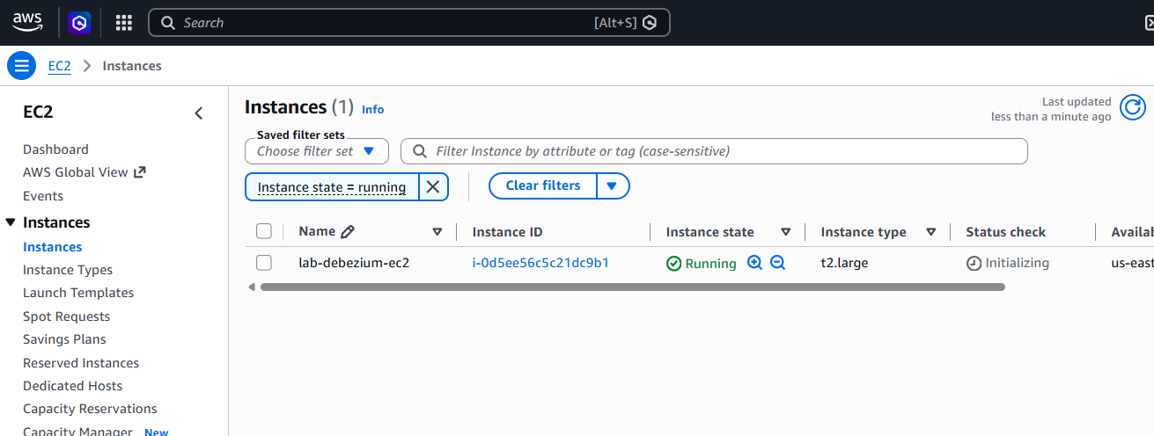
- Make sure the EC2 instance is running and review the configuration in the AWS console at https://us-east-1.console.aws.amazon.com/ec2/:

Section 3: Create a cloud MySQL database hosted on RDS and initialize data, streaming tables
- In the first two sections, we made sure to deploy a cloud storage instance on S3 and a cloud virtual machine on EC2 for hosting streaming services. Next, we are going to deploy a SQL Database leveraging Amazon’s PaaS Relational Database Service (RDS). For this lab we will be leveraging MySQL as the database provider and our data source.

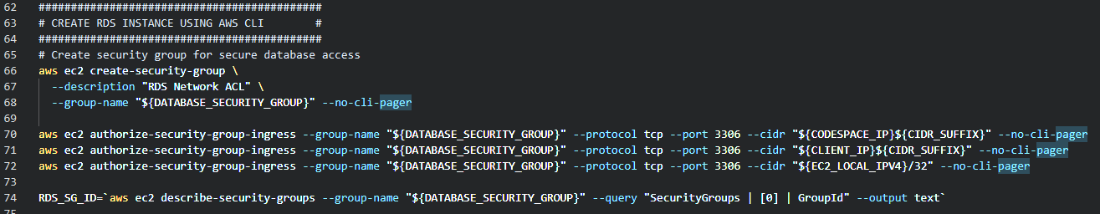
- First, create a new security group specifically for secure database access. This will allow your Codespace instance, streaming environment on EC2, and PC to access MySQL on port 3306:

- The Debezium MySQL connector is dependent on the binary log to capture changes. This section of code creates a database parameter group which overrides some of the MySQL defaults for compatibility with Debezium:
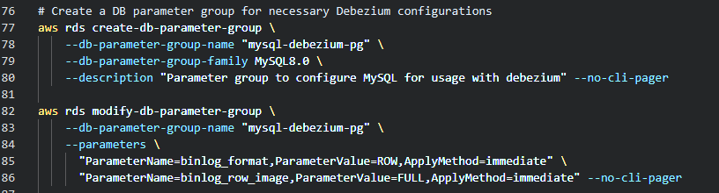
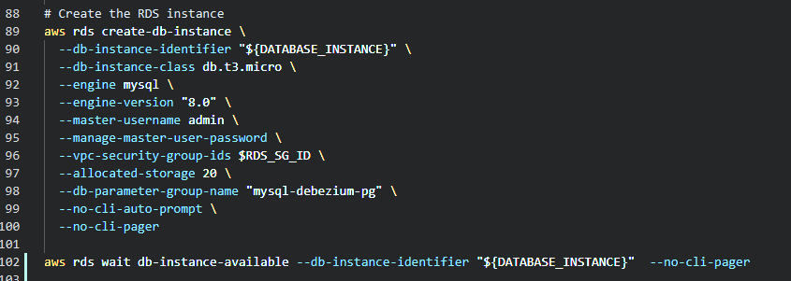
- Create the RDS instance, associating both the security group and parameter group with the new MySQL database. Note that the aws rds wait command will block until the database is available. It is necessary to wait before moving on to the next steps. It takes potentially 5-10 minutes to spin up the RDS instance.

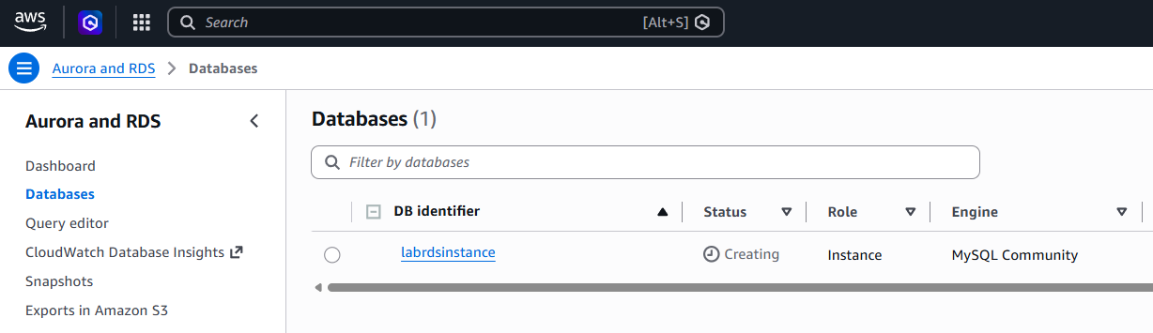
- Open the RDS console and view your new database instance by clicking ‘databases’ at https://us-east-1.console.aws.amazon.com/rds:

- We are leveraging the MySQL employees database to populate sample data and explore streaming data collection. This database is documented here: https://dev.mysql.com/doc/employee/en/. The following section of code downloads the database initialization artifacts from Git. Note that when you use the MySQL command line interface, you are connecting from Cloud9 to your remote RDS instance hosted by Amazon.

Database initialization:
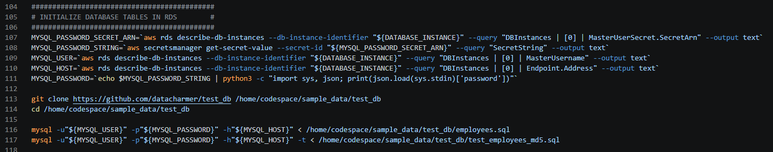

Database output:

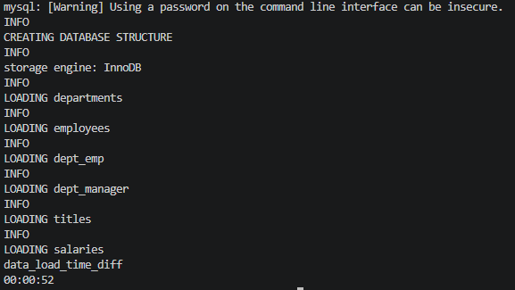
Database tests:
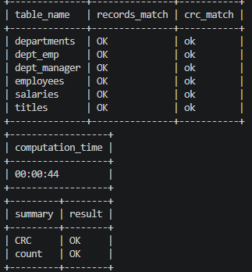
- Rather than stream directly from base tables, we want to avoid an overly large initial load (Debezium snapshot load) from these tables. Instead, we are creating empty copies of these tables and populating them with a subset of data to better manage load on our lab environment. We will insert, update, and delete records later in the lab once streaming services are up and running.
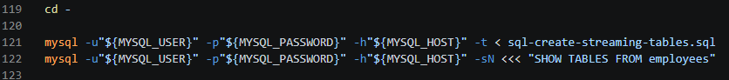

- Validate tables leveraging the SHOW TABLES command:
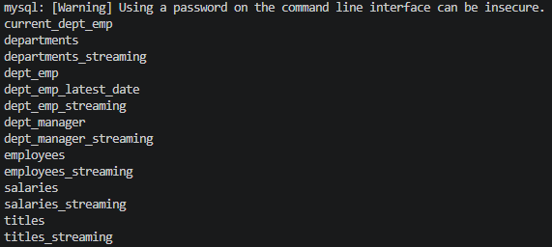

Section 4: Start Debezium services and load Confluent S3 sink connector
- Run the following section of code to copy files and open an SSH session with your running EC2 instance created in section 2. Note that we are copying the Confluent S3 connector (zip file) so that we can install it on our Kafka Connect instance later:
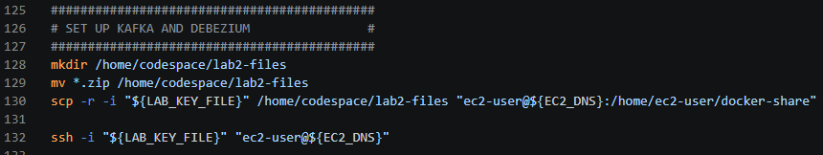
ASCII art welcomes you to the Amazon Linux instance:
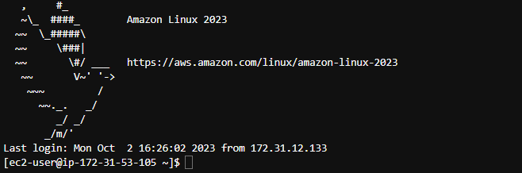

- You will be using docker to run different services on this machine: Zookeeper, Kafka (brokers), Kafka Connect with Debezium/Confluent connectors, and Debezium UI (currently expiremental). Run the following section of code to install and configure Docker and prepare the Confluent connector for installation on Kafka Connect:
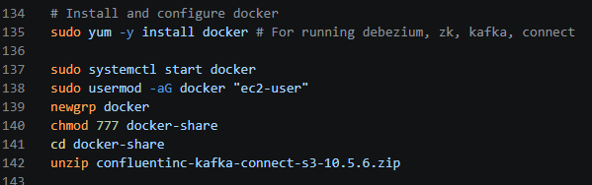

- As discussed in class, Kafka may rely on Zookeeper for cluster configuration management and consumer-partition offsets. Zookeeper needs to be up and running before we start Kafka. Note that we are leveraging the Debezium docker image to run Zookeeper, Kafka, Connect, and Debezium services. Query the logs until you see the following output indicating that Zookeeper is up and ready to take requests.
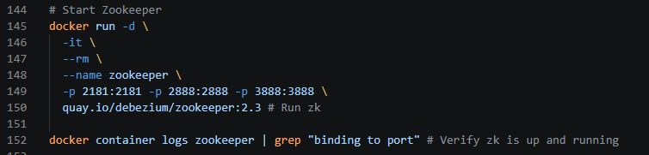
Starting Zookeeper:

Zookeeper running and ready to take requests:

- Now that Zookeeper is up and running, we can start Kafka. Note the docker link, ensuring that the Kafka container can access services running on the Zookeeper container. The link feature may be deprecated in a future Docker release, but is still used by these Debezium containers.

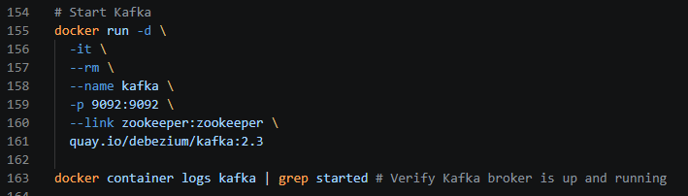
Starting Kafka:

Kafka running and ready to take requests:

- Similarly, we are now ready to start Kafka Connect. Note the volume mapping which places the extracted Confluent S3 sink connector in the plugins directory on Debezium, allowing us to integrate with S3. Additionally, there is a link to enable the dependency between Kafka Connect and Kafka.
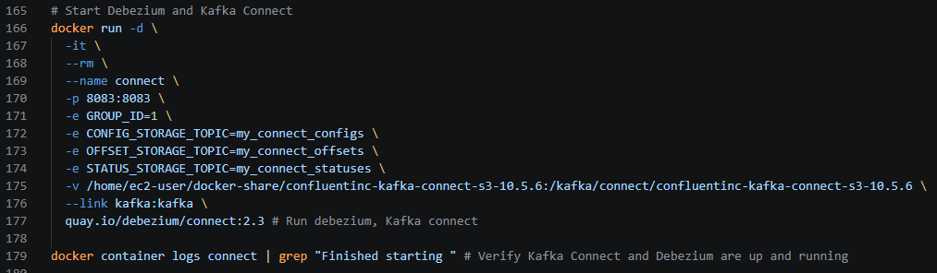
Starting Kafka Connect:

Kafka Connect running and ready to take requests:

- Finally, start Debezium UI. We will take a brief look at this service to validate our Debezium connector in the next section. Once you have started Debezium UI, you should switch back to your first terminal session in Cloud9.

Starting Debezium UI:
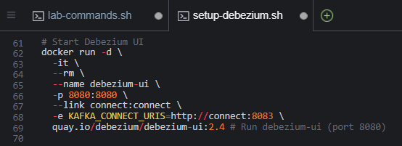
- List Kafka topics. Now that all of our Kafka and Debezium-related service are up and running on our EC2 instance, exit twice to return control back to your GitHub Codespace machine. You should see the shell user change from ec2-user to your GitHub account name. 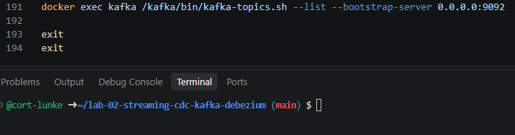

Section 5: Deploy and validate a MySQL source connector and an S3 sink connector on Kafka Connect
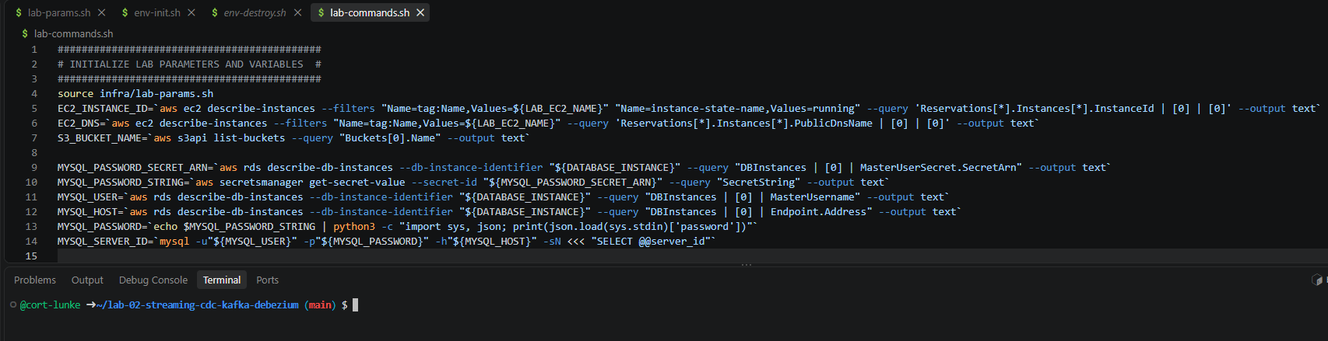
- Time to open and run lab-commands.sh. In this section, we will be deploying connectors to Kafka Connect leveraging its REST API. Make sure you have exited the EC2 instance and you see your GitHub account name in the terminal.

- Leverage curl to invoke the Kafka Connect REST API and create our source connector. Note that we are passing important database details including the host, user, and password. Additionally, we specify the databases and tables to include, as well as the location of our Kafka servers (among other configs).

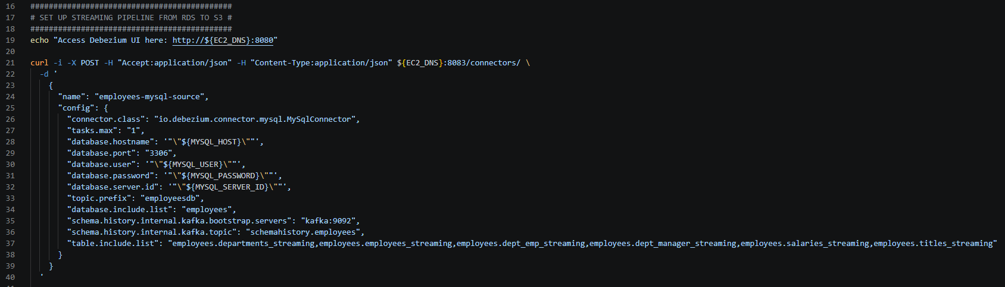
JSON request to create MySQL source connector:

API response: 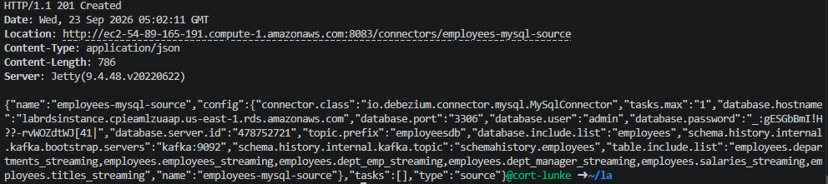

- Next, we’ll start the sink connector to stream data from Kafka topics to AWS S3. Note that we are setting S3 details, the Confluent connector class, storage format for database events, topics for monitoring, the path to output in S3, and behavior for null values to capture delete events (among other configs).

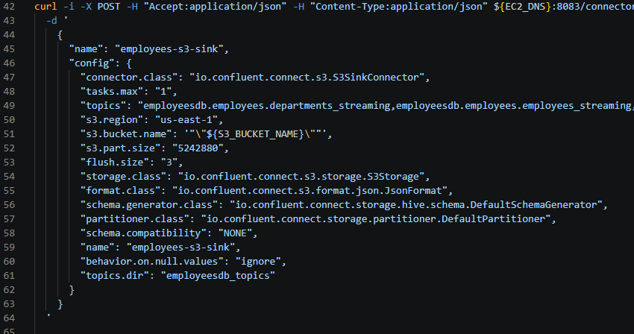
JSON request to create S3 sink connector:

API response:
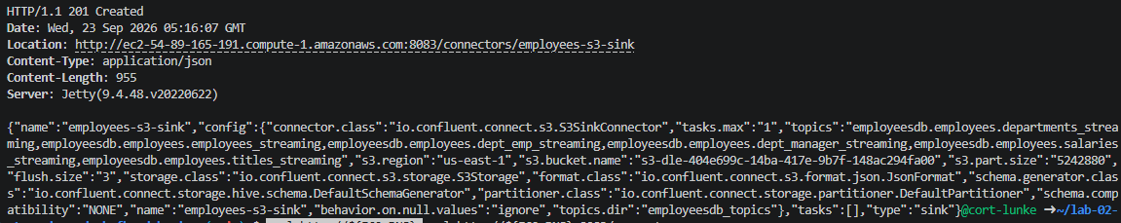
- Next, navigate to Debezium via the URL printed to your terminal. If you remembered to update and save lab-params.sh with your appropriate IP address then you will be able to access it fine. If you forgot, you may add a new firewall rule manually in the AWS console.

Debezium URL:
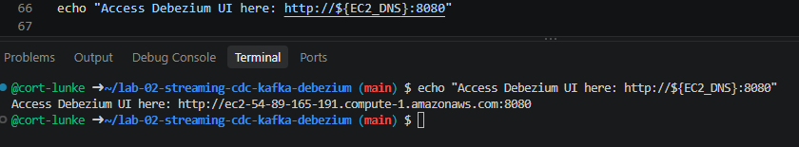

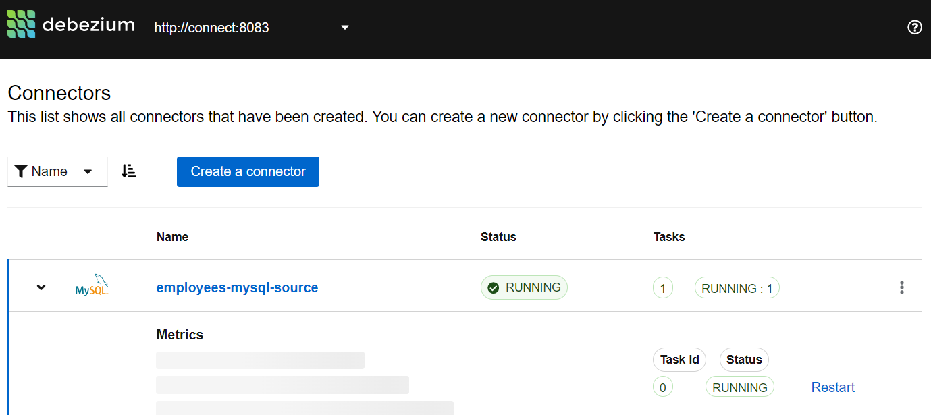
Debezium UI:

- The Debezium UI only shows the status of connectors and tasks for Debezium connectors at this time. We can leverage the API to check the status of both the MySQL source and S3 sink connectors.
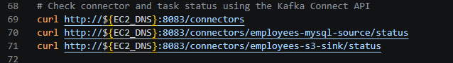

Section 6: Validate create, update, delete, and read (snapshot) operations in MySQL and Debezium
- In this section, we will be performing create, update, and delete operations within our source database. If previous sections have been completed correctly, you should see events flowing from your SQL database all the way to your cloud storage in S3.

- Connect to your RDS instance using the MySQL command line interface. Input commands from sql-generate-sql-records.sql, starting with insert commands.
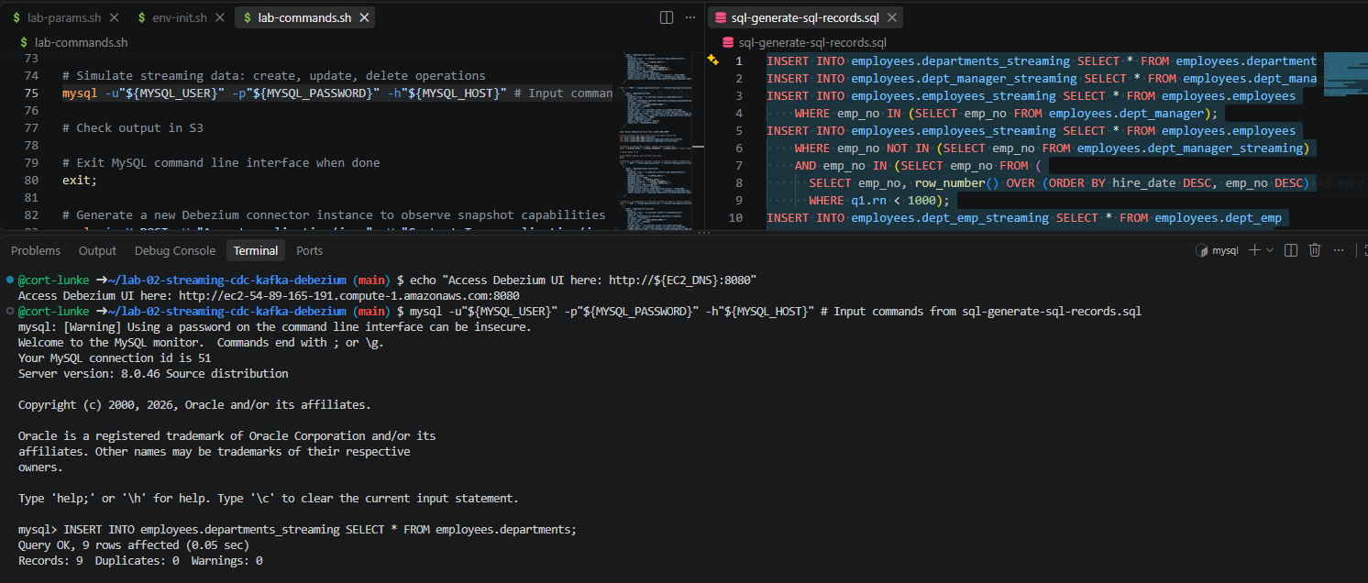

- Once all insert commands have completed, inspect the create events being stored in your S3 bucket at https://s3.console.aws.amazon.com/s3. Leverage the console to inspect, download, and view insert events. Note that the “before” state of the row is null for a create, while the “after” state will have the values for the new row. Inspect the other metadata associated with the new row including table name, database, log file, etc.

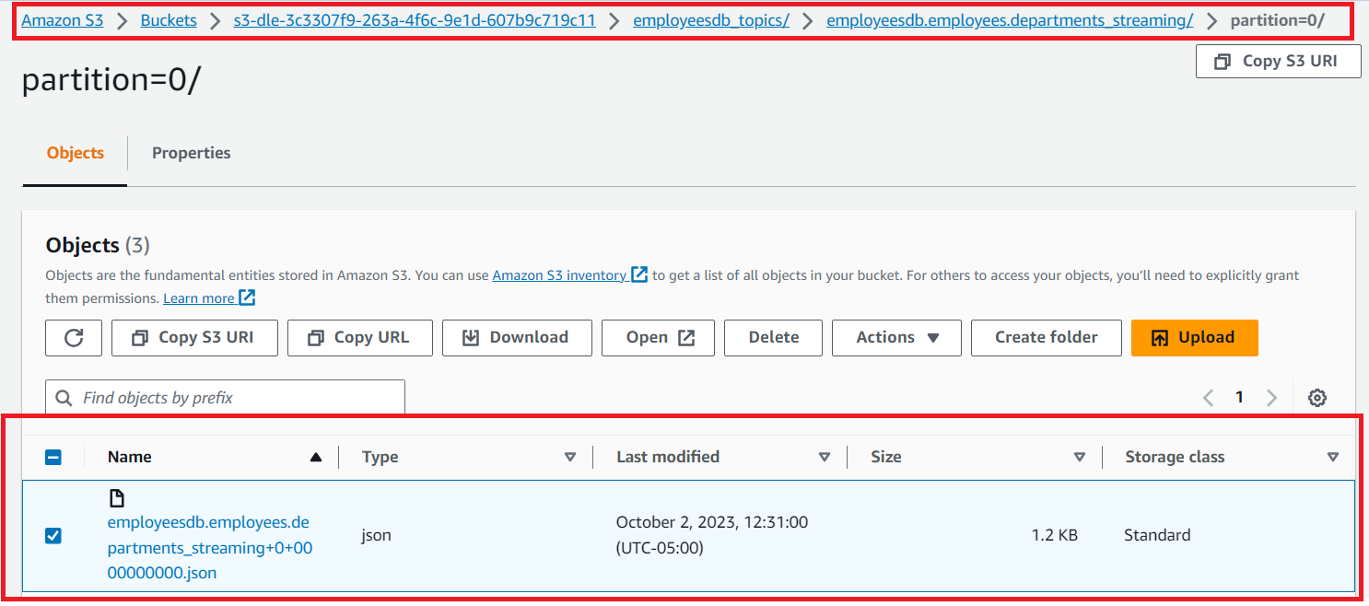
Browsing your S3 bucket:

Viewing insert event details: 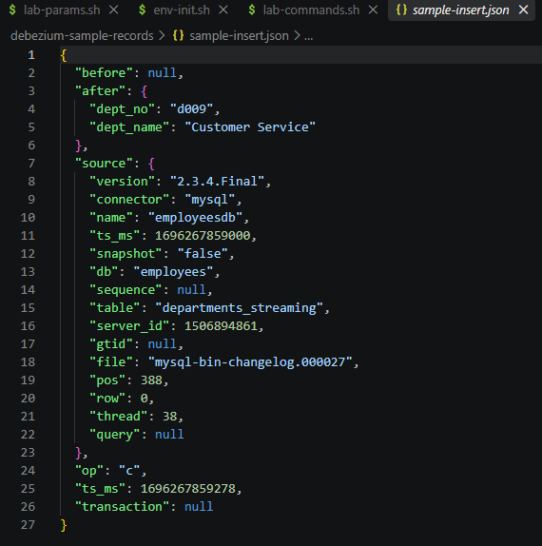

- Next, generate some update events. Business is good and we are giving managers a raise, increasing their salary by 10%. Note that this is for demo purposes only and we will not be leveraging from_date or to_date, but doing in-place updates on the salaries_streaming table:
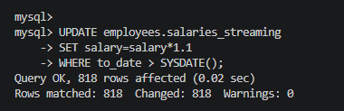

- Inspect the update events being stored in S3, taking note of the before/after state of the row and salary increase:
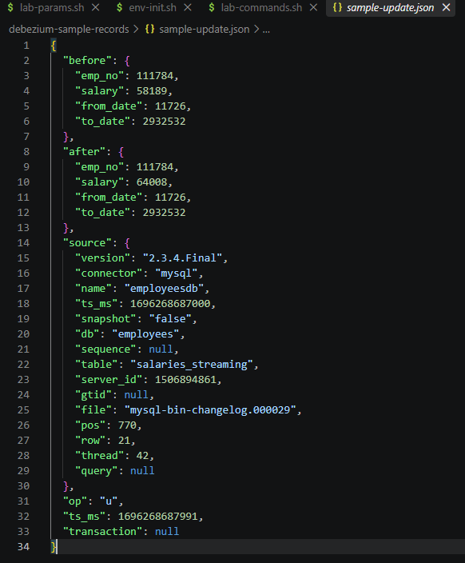

- Business is no longer strong and we will need to lay off some employees to cover the raises given to department managers. We unfortunately will be deleting some employees from the employees table and inspecting the delete events captured by Debezium and stored in S3.

- Inspect the delete events propagated to S3: 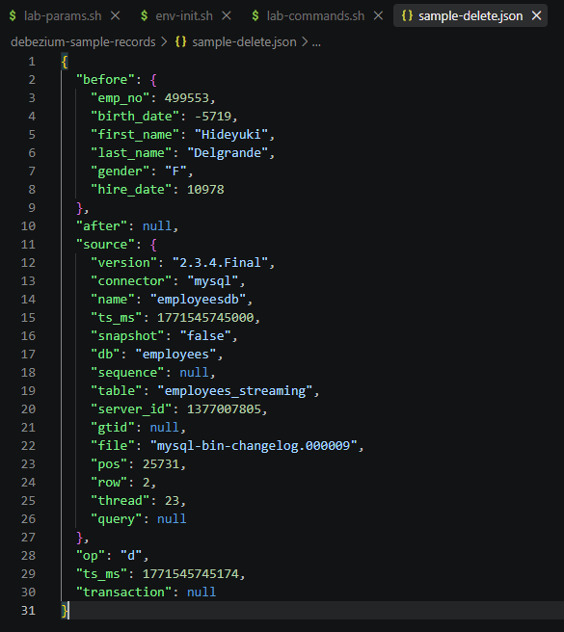

- Finally, we have a new data pipeline to set up. Let’s inspect what happens when you deploy a new Debezium connector on existing tables. Note that you can exit the MySQL command line with the exit; command.

New source connector:
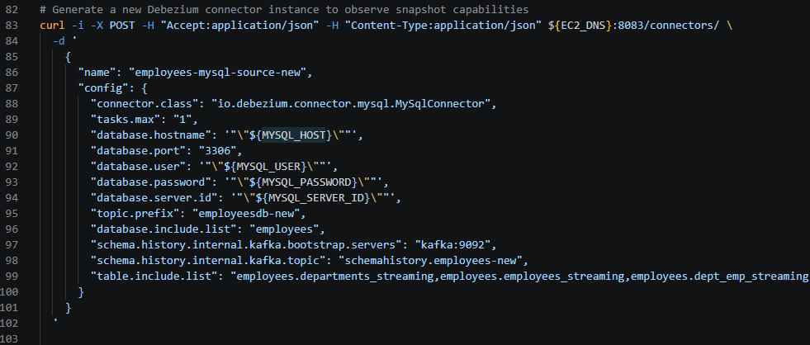

New sink connector: 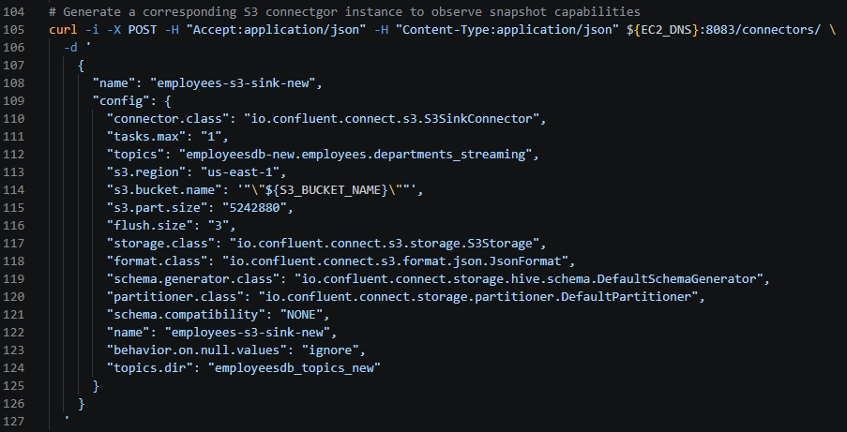

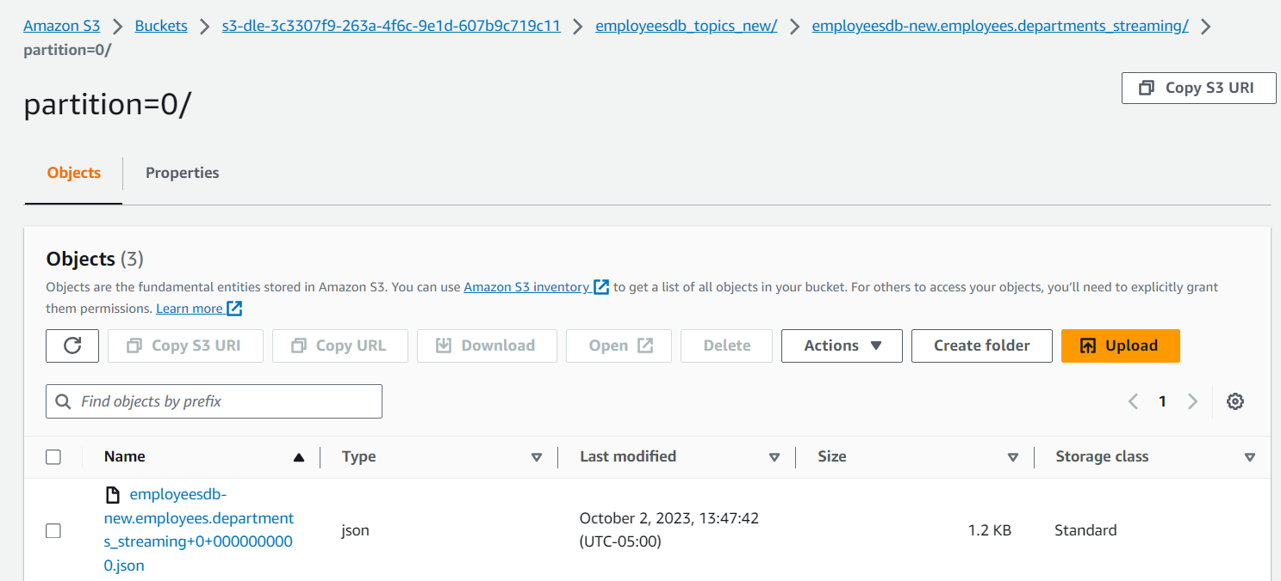
- Observe the new paths created in S3 and note that all the new backend topics have been recreated for this new connector. Note that Debezium has propagated the current state of the tables in a snapshot read operation, leveraging an operation code of “r” (for read).

- These are similar to create events but the “r” operation code indicates they have been created from an initial snapshot:
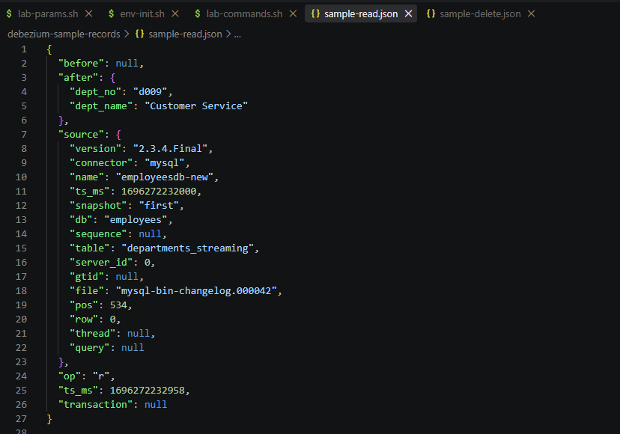

Section 7: Remove lab resources
The env-destroy.sh script will clean up your lab resources including an:
- EC2 instance, associated keypair, and associated security group
- RDS instance, associated security group, and associated parameter group
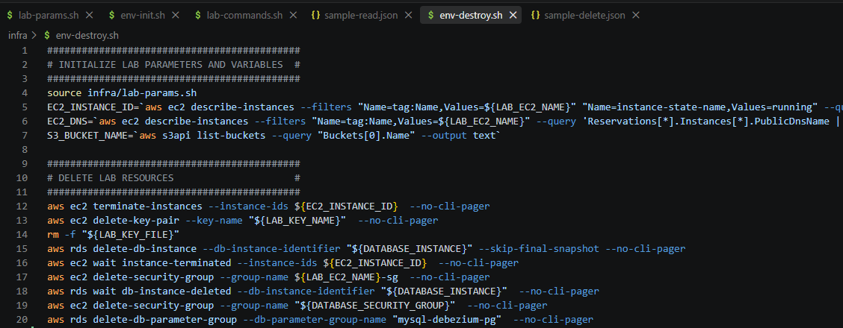

Conclusion
In this lab, you were able to perform data collection from a cloud SQL data source all the way to cloud storage leveraging a mature streaming architecture. By combining Kafka topics with native Kafka Connect capabilities and third-party Debezium and Confluent connectors, you were able to build an architecturally elegant, low-code, resilient streaming solution for your data lake. In later labs we will not only collect but also prepare and analyze data streams in a data lake environment.

